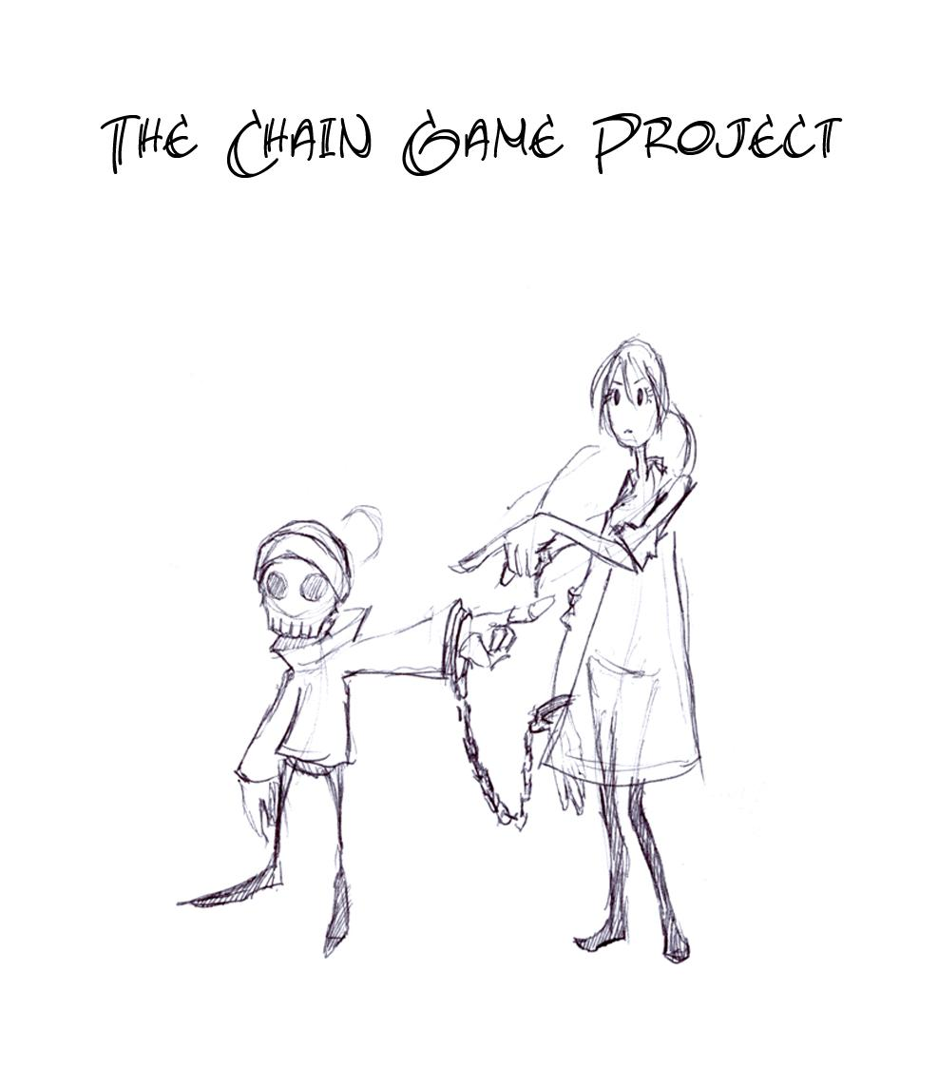
Table of Contents
Executive Summary (BRIAN) 4
Introduction (BRIAN) 5
Game Design 6
Tone (NEEDS APPROVAL) 6
Chain Abilities (APPROVAL) 6
Character Design (NEEDS APPROVAL) 9
Primary Characters – Melvin Death 9
Primary Characters – Sophie Broadway 13
Level Design (MICHAEL) 16
Overall Level Progression 16
Hell’s Gate 16
The Promenade 17
“Small World” 18
The Zoo 18
The Castle 19
The Death Machine 19
Backstage 20
User Interface and Controls (DAN) 21
Sound Design (NEEDS APPROVAL) 22
Technology 22
Characters 22
Sound Effects (NEEDS APPROVAL) 24
Music and Ambience (INCOMPLETE) 24
Technical Design (INCOMPLETE) 25
Platform Specifications and Constraints (NEEDS APPROVAL) 25
User Machine Specifications (INCOMPLETE) 26
Gamebryo Engine (INCOMPLETE) 26
Chain Physics (NEEDS APPROVAL) 26
UML Class Hierarchy (NOT STARTED) 27
Art Design (NEEDS APPROVAL) 28
Environment (NEEDS APPROVAL) 28
Main Characters (NEEDS APPROVAL) 31
Pipeline (INCOMPLETE) 36
Tools (NEEDS APPROVAL) 36
Art Pipeline (NEEDS APPROVAL) 36
Pipeline Overview 37
Automation 37
Blue Box Level Design 38
Asset Lists 39
Sound Asset List (NEEDS APPROVAL) 39
Technical Asset List (BOBBY) 43
Art Asset List (NEEDS APPROVAL) 43
Risk Analysis (MICHAEL) 47
Chain 47
Number of Levels 47
Personnel 48
Fun Factor 48
Chained Cooperative Mechanic Ill-suited to fast paced Gameplay 48
Production Planning (DAN & BRIAN) 50
Milestone Schedule (DAN & BRIAN) 50
Development Methodology (DAN & BRIAN) 50
Appendix A – Chain Move Animations 50

Executive Summary (BRIAN)
Start typing here.

Introduction (BRIAN)
Start typing here.

Game Design
Start typing here.
Tone (NEEDS APPROVAL)
The tone words for our game are morbid and humorous. Justifications of why we chose these words are below:
Morbid
Our game begins with a young woman (Sophie) dying and chained to the grim reaper’s skeletal intern (Melvin) who is tasked with bringing her through the afterlife and ultimately returning her to the mortal world. The afterlife is filled with creatures that are too odd and creepy for the likes of Earth. However, one character happens to be just another normal guy but what makes him morbid is that his sole goal in the afterlife is to kill himself by whatever means necessary.
Our various chain moves reflect this morbid world as well. For example, one move has the player kicking another player over and using them as a sled while another has a player throwing another player into a wall and using their body as a platform. Finally, one move requires that one player be lit on fire and drag the other player helplessly behind them. We feel that morbid fits as a tone word based on these situations.
Humorous
We are portraying the afterlife as a facade. Cardboard cutout flames will be taped onto sticks which are then attached to rundown machinery. Big hulking demons will in actuality be tiny men in huge, oversized suits with big visible zippers. Torture chambers will look torturous from the front, but they are all made out of foam and rubber.
Some chain moves that seem morbid can be viewed as humorous. For example, a character’s head sticking into a wall or the top of a ledge seems reminiscent for old cartoons. A character being lit on fire can be viewed as humorous based on their reaction to the heat. Lastly, moves that require characters kicking or stepping upon one another can be made humorous by making their bodies stretch or squish depending on the move.
Chain Abilities (APPROVAL)
Moves specific to the chain will be listed here. Movement considered standard to the platforming genre such as walking, running and jumping will not be listed. The moves listed are not specific to one player.
Punt Kick
One player will kick the other player into the air. The player that has been kicked will then grab the chain and swing it sideways to fling the other player around them to grab onto a ledge or land on a far off platform. This allows both players to cross gaps that they wouldn’t have normally been able to cross with a standard jump.
Chain Pull (players)
Either player will be able to pull the other player. This can be used to pull them out of the way of danger or pull them up onto a platform if they have fallen off.
Anchor
Either player will be able to anchor themselves which will cause them to no longer be pulled by the other player. This is useful if one player is pulling the other around and they are tired of being pulled. This can also be used if one player falls off of a platform. The other player can anchor down and prevent them from falling.
Springboard
Similar to the Punt Kick, this ability will be used to reach higher areas than could not be reached by a standard jump. One player will jump on top of the other, causing them to jump much higher while the other player gets squished. The player in midair will swing the other around them (causing them to return to a normal shape) and reach the higher ground.
Wall Kick
Players will be able to kick off walls to reach higher areas. This move can be done by one player to grab onto a high ledge, or as a team to slowly ascend up a small shaft.
Dart Throw
One player will be able to grab another player, jump, and throw the other player directly into a wall. Their head will be stuck in the wall for a short time, while their body will stick out and become ridged. This allows it to be used as a platform for a short time.
Chain Trip
The players have the ability to trip one another. This can keep troublesome players in line or simply be used as a taunt.
Chain Pull (objects)
Using the chain, players will be able to pull objects of various sizes. A small object could be grabbed and carried by one player. A medium size object can be grabbed onto by one player, while the other player pulls the player holding onto the object. A large object will be moved by having the chain tossed around it and both players will pull the object slowly.
Shaft Ascent
One player will be able to grab onto a pole at the center of a circular room and climb up and down it. The second player will be able to run alongside the wall and slowly navigate upwards. The player on the pole will need to climb up and down it in order to keep up with the player running along the wall.
Pole Traversal
Both players will have the ability to climb up and down vertical and across horizontal poles. They will also be able to swing back and forth on a pole and jump off to reach higher areas.
Idle Chain
During the game if both players stand idle for long enough, the players will automatically untangle the chain if it is tangled and start swing it around like a jump rope.
Upward Hammer Swing
One player will be able to swing the other player upwards into a ceiling. The impact will cause one player's head to be stuck in the ceiling, leaving them hanging there for a short time. The other player will then be able to swing across a chasm or around another obstacle.
Downward Hammer Swing
One player will jump and swing the other player over their head. The player who was swung will come crashing toward the ground with force.
Hanging Off A Ledge
If one player is anchored and the other is hanging off a ledge, the player who is hanging off the ledge can kick off a wall and swing around.
Body Sled
One player will be able to kick the other player down and use them as a sled to traverse large slopes.
Zip Line
Players will be able to throw a chain over a slanted horizontal pole and slide down it in order to travel across a level quicker or to reach previously inaccessible areas. This move will most likely be context sensitive.
Animal Reins
When riding an animal, both players will have the ability to pull their part of the chain or let it hang normally. This will tighten or loosen the chain around the animal’s mouth accordingly and guide the animal in a specific direction.
Inflation
Using a source of air, one player will inflate like a balloon. This will cause them to float and drag the other player along with them. This will allow both players to reach previously inaccessible areas.
Fire Rocket
If one player is put near a source of heat, they will fire off like rocket allowing them to traverse large areas. The unheated player will need to aim the second player toward their desired destination. This will allow both players to reach previously inaccessible areas.
Garrote
The players will have the ability to wrap the chain around and object and then run in opposite directions. The tightening chain will split the object it is wrapped around in two.
Character Design (NEEDS APPROVAL)
Primary Characters – Melvin Death
Razor
A largely underappreciated character who can only be pushed so far, that tries to succeed but ultimately fails. Comedically.
Personality
A passive, timid character who despite getting nowhere in life is determined to succeed. He is in the lowest rung of his profession and shows no signs of any advancement. Although taking on any task with gusto and enthusiasm, he is completely ignored by his superiors and ridiculed by his peers and just about everyone else in the underworld that knows him. He is also highly self-critical and under-confident (the exact opposite of your stereotypical grim reaper). His moment of glory would be after taking a barrage of the girls barbs and demands, he finally snaps. Backed into a corner and beaten down by her, his passive aggressive character would suddenly open the floodgates, silencing her with a sudden torrent of pent up counter abuse.
Traits
Avoiding direct eye contact with Sophie, raising his brow (hat), pulling the hat over his head to muffle his cursing at her when she begins to push him over the edge (Yosemite Sam). Sighing deeply, venting pent up frustration and energy. He would be regularly talking to himself trying to keep calm (“I can do this, you gotta do what you gotta do, I’ll be rid of her soon, yeah I’m sure to get that promotion this time, no I can’t fling her into that pit, stay calm, keep focused Melvie you can do this……..”)
Relationship to Sophie
For Melvin, dealing with Sophie would be a saintly exercise in tolerance and patience. She would be relentlessly driving him insane and trying to undermine or question his every decision. He would be stuck between a rock and a hard place in the sense that on one side he has to endure her incessant annoyances and on the other he has the threat of his boss doing horrible things to him if he fails. While the chain would be a minor inconvenience to the girl it would be an utter nightmare for him, being physically stuck with her. He would be constantly trying to suppress or gently expel the mounting ball of negativity, trying to compartmentalize the whole experience and her as just part of his job. While his job is to escort her, at times Grim will feel a perverse glee at her suffering, countering the mental anguish he receives from her.
Relationship with Secondary Characters
Grim would either know these characters or be known by them. He would be the subject of ridicule and mockery to his peers. This society would embrace a morbid mentality where poking fun at someone’s faults, tripping them over, or causing general humiliation and suffering is the normal way of life. The entire staff of our hell theme park may have already reached a hopeless and chronically depressive mental state, using black humor and morbidity as their primary form of entertainment.
Relationship with the Environment
As Melvin dwells in this environment he would be largely unaffected by and towards it, he would at least seem to know where he is going unlike the girl. He may have a greater respect and pride for his ‘hometown’ than she does almost taking on the role of impromptu tour guide (“hey just wait until you see the fire breathing giraffe pit…. They’re going to be made of cardboard again aren’t they?.... No wait you’ll see they’re really scary, one of our biggest attractions no expense was spared, we didn’t even use any duct tape this time”. At times, Grim may take his frustration out on the environment.
Characters like him
- Ickis from Aaahh!!! Real Monsters
- Milo and Bob Oblong from The Oblongs
- Professor Chaos/Butters from South Park
- Daffy Duck from Looney Toons
- Alec Thames from An Uzi at the Alamo
- Slinkman from Camp Lazlo
- Smithers from The Simpsons
- Principal Skinner from The Simpsons
- Kif Kroker from Futurama
- Charlie Brown from Peanuts
Melvin Rip-O-Matic
(See overleaf)
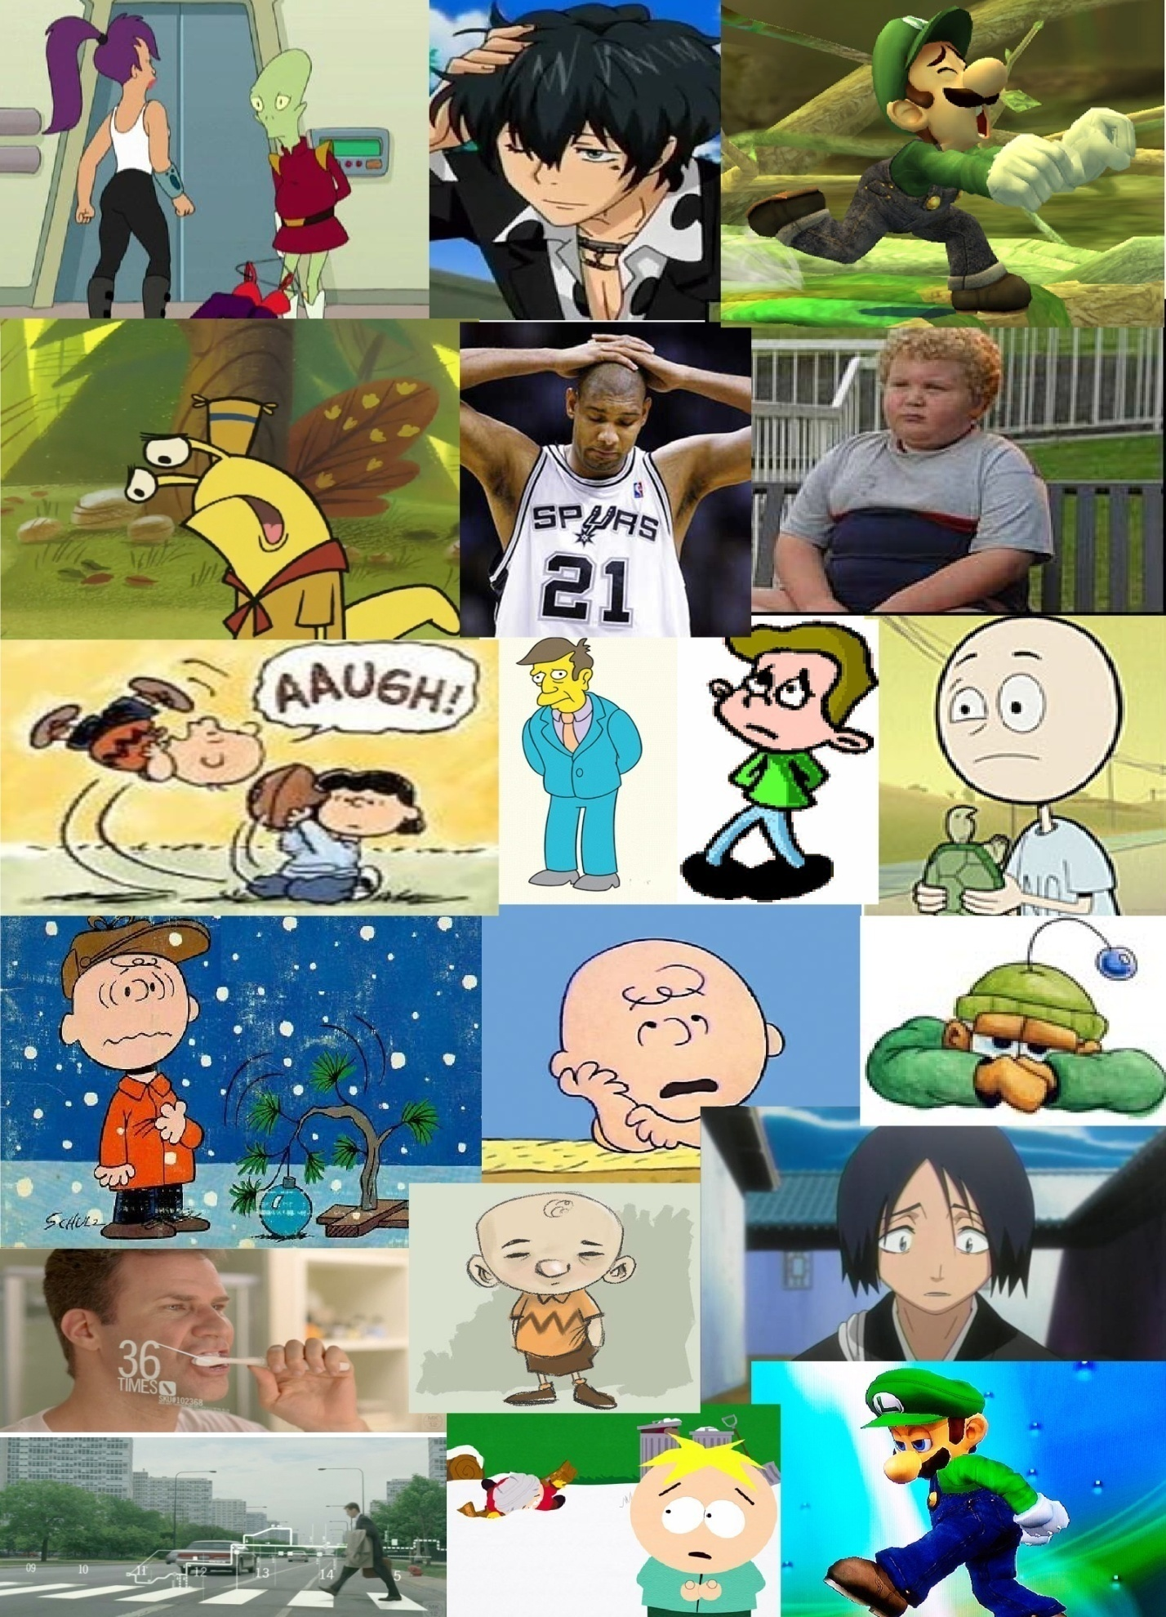
Primary Characters – Sophie Broadway
Razor
A spoiled, slightly ditzy daddy's girl who is old enough to be independent but still relies on her father's money and at times can come off as offensive. When necessary, her odd knowledgebase allows her to do what it takes to get things done because she considers her time too valuable to waste.
Personality
A highly assertive individual who always attempts to control the situation even if it is completely out of her control; she would try to insist on going down ‘that path’ despite having no idea where it actually goes and being advised to the contrary. Additionally, she would be somewhat spoiled, a twenty something year old brat, used to others carrying out her will. She would naturally assume that she is the center of attention and that she is at least one social level above everyone else, if not several.
Traits
Impatient (Tapping Foot), Self Grooming (Hair, Fingernails), shows distinct lack of enthusiasm or interest (glares, head resting in hand, fidget, pacing)
Relationship with Melvin
The two characters are in a situation of mutual survival where they both need one another to accomplish their goals; in her case, it is returning to the land of the living, in his case, it is avoiding the wrath of his boss by carrying out his job. The Girl knows that the Intern has been ordered to escort her and since he has no alternative, she is free to rip on him as much as she likes without losing him as an ally. She is not beyond using below the belt barbs such as calling him ‘Shorty’, turning his own words on him (arguments), or mocking his poor standing in the underworld. She would also show some surprise / puzzlement / irritation as to why he seems to have absolutely no interest towards her emotionally or physically.
Relationship with Secondary Characters
She will treat most of the secondary character little better than the intern, if they are not of immediate help, she dismisses them. The exception would be any characters in real social power or leadership roles; for example our ‘demon in the green suit’, whom she would be more likely to treat with at least initial respect.
Relationship with the Environment
Disinterested, skeptical and largely unimpressed, she will view the hell as a shoddy illusion and a second rate performance from the word go. This is unless she is thrown into any real danger, at which point she would rely heavily on the intern to keep her alive, although he certainly won’t receive any gratitude for it. In regard to the moves, while Grim is dead and will not feel any pain or fatigue (for example when his head is thrust into a rock face), the girl will not be so fortunate.
Characters like her
- Kira Nyres' intro scene from Star Trek: Deep Space Nine
- Donna from Dr. Who
Sophie Rip-O-Matic
(See overleaf)
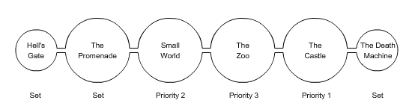
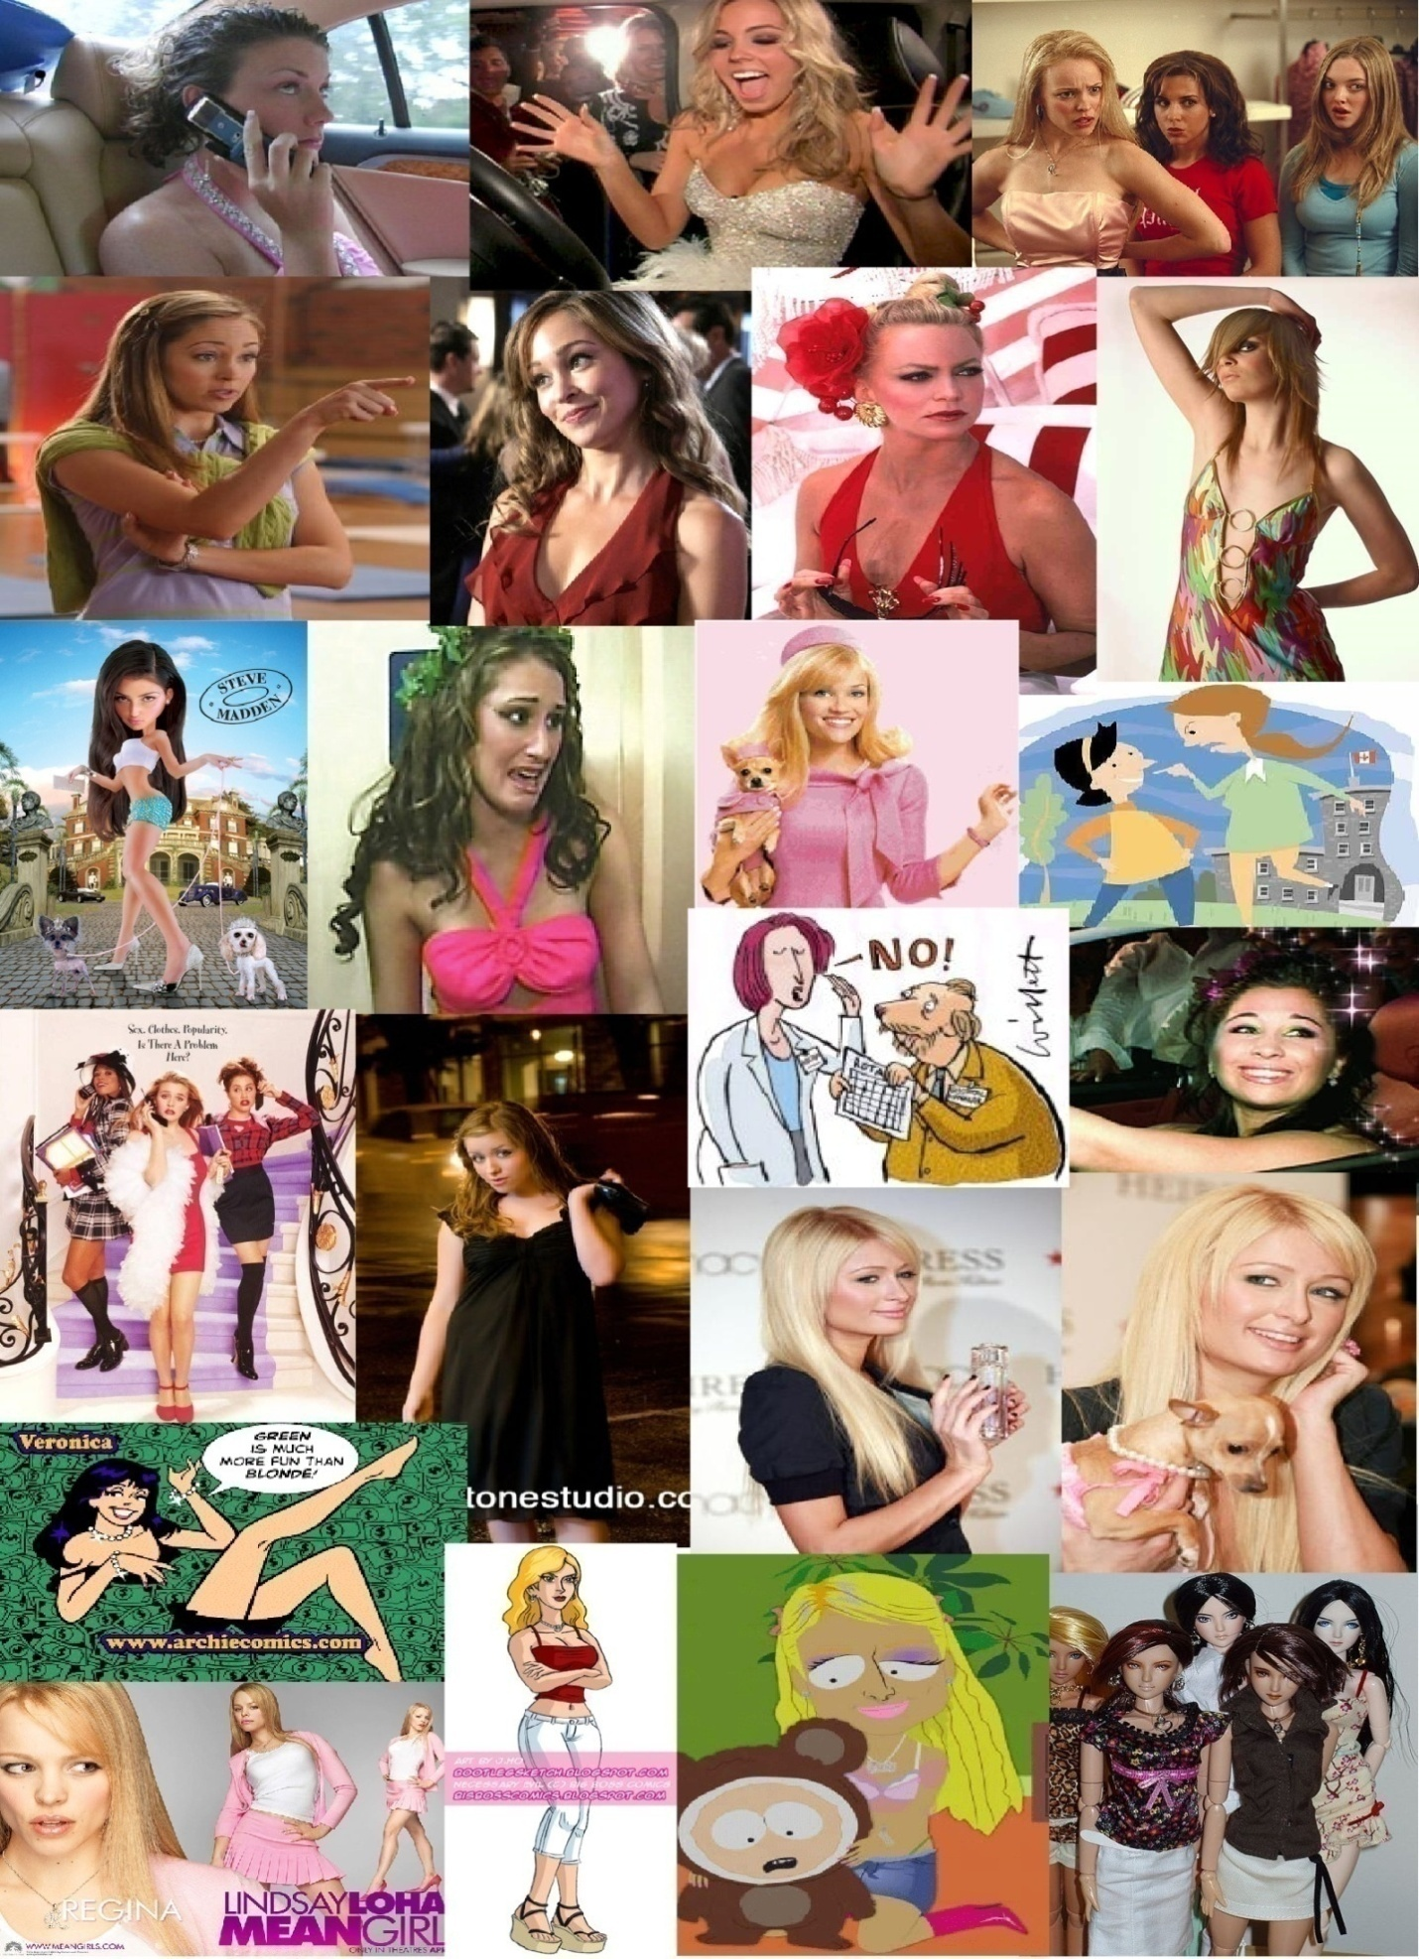Level Design (MICHAEL)
Overall Level Progression
Hell’s Gate
Description
The welcome area to hell for the recently deceased, this will very much tap the Dante’s Inferno style of entrance. This opening area will very much portray a typical fire and brimstone hell where the condemned would begin their journey through the afterlife. Sophie will arrive in hell here to be greeted by Melvin who will instead take her through a backdoor route exposing the entire front entrance as a cardboard and wooden sham.
Design
Hell’s gate while smaller than the main stages will look immensely large and intimidating. Its primary purpose is to act as a short linear tutorial area. During this stage the fake nature of hell will be demonstrated, and then the linear path will lead to a reveal point and wow moment showing that hell is a giant theme park.
Gameplay
This area will be designed to allow the players to ease into the game with the starting area wide open letting them get used to the chain. This will be followed with some basic jumping areas and minor platforming challenges.
Possible Items of Interest
- Lava river of Styx’s with the boatman
- Coffins sinking out of the ceiling landing on the ground
- Massive gate
- Fire plumes, volcanic geysers, cracks in the ground
- (Also see Asset List)
The Promenade
Description
The main boardwalk and central area of the theme park. The stage will be full of morbid and bizarre attractions, spectacles and characters. In the distance a large castle would act as a major point of interest and centerpiece to the theme park.
Design
This would be a largely open plan area with carnival games drawing the players interest. If players try to get closer to the castle they will find their route blocked by a large undetermined secondary character. Nearby the players can enter the “Small World” ride.
Gameplay
Platforming would be deemphasized in this area; instead, the players would be encouraged to learn the more advanced moves by playing a variety of carnival games throughout the promenade.
Possible Items of Interest
- Background attractions / torture devices may include house of mirrors, ferris wheel, carousal, stalls
  - Roller coster / vomit
  - Syspohius on a cigarette break
- Mechanics themed carnival games (list forthcoming, examples below)
  - Wack-a-mole using the ground pound
  - Test your strength bell game with the ground pound
  - ‘Plinko’ using the dart throw.
- Outskirts of this Promenade could be a ‘shanty town’ full of poor characters trying to exploit tourists
- “You must be this tall to enter the park” area, may explain why the pair are chained (girl as guardian) or why they can’t directly get to the park / attractions in the background
“Small World”
Description
A single large themed ride featuring numerous props and animatronic characters cutely torturing in the background.
Layout
Players would ride a moving platform avoiding various obstacles that could knock them off or snag the chain. At times, players would have to get off the ride to avoid these obstacles. They would leap to and from the ‘river bank’ to get backstage and keep up with the platform.
The platform would not be on water, but floating over a bottomless chasm. This would give us opportunity to introduce Suicide Steve (see Characters).
Gameplay
Keeping up with a moving platform along a fixed course.
Items of Interest
- Singing robotic creatures in various states of functioning, torturing souls
  - Axes that hit the boat
- Plywood scenery that players need to avoid while standing on the boat
The Zoo
Description
A nightmarish carnival of monsters and ironic creatures.
Design
A more maze-like area in which players must go in and out of creature cages to return to the path to the castle
Gameplay
Each of the animals will be designed to exploit a chain mechanic. For example, our bird with sticks for a beak can be lit on fire with the fire rocket, or our mushroom creature could be a jumping platform. Additionally, our players could go on-top of cages, and have these odd creatures reach out and attempt to swipe at them.
Items of Interest
- Odd animals that are functional to the players (see concept art)
- Food baskets w/ souls
The Castle
Description
The centerpiece of hell, the devils castle is a towering structure with twisted battlements
Design
A large tower like structure with players traversing both the interior and exterior.
Gameplay
A major platforming challenge (see concept sketch of exterior). The interior would be a more frozen area where (if technology allows) players will slip on the floor to test their jump timing skills.
Items of Interest
- Anamatronic devil controlled by Suicide Steve (Great and Powerful Oz)
- Chyrogenically frozen Devil (Walt Disney “Our Founder”)
- Chain platforms along the exterior
- An interior that is in a state of disarray from being disused / slapped together (in keeping w/ our backstage theme)
- Devil’s throne as tourist trap
The Death Machine
Description
Suicide’s Steve’s final solution. He’s tried every way to kill himself, now he’s trying every way… at once! A mangled amalgamation of various props he’s scavenged from the park. This machine may block the exit from Hell or drawing power from the means to escape hell. This will be of smaller scale, like the gate area, but will be the ultimate challenge.
Design
Spinning buzzsaws, crushing walls, anything you can think of will be trying to kill these players. Think a more factory, meat processor kind of feel with this environment. You will be able to see Steve try to suffer in this contraption, but will exit (like our players if they are skilled enough) unphased.
Gameplay
The most challenging area that tests the abilities of players in each of their skills (see ‘the gauntlet’ from the pitch presentation).
Items of Interest
- A door that our girl leaps towards, that says ‘exit’ but unwittingly leads them inside the machine
- Shaft ascent?
- Previously seen pieces from the environment (anamatronic tortures, animals, etc.)
  - In other areas, elude to missing ride parts?
Backstage
Description
Not a stand alone environment, but an aspect to nearly all of our areas. Similar to the back stage of a theatre production or the heavily duck taped backside of rides in theme parks.
Gameplay
Note main area where background section is placed and re-enforce that theme (i.e. mechanically and aesthetically compliment the Zoo, ‘Small World’, etc. ).
Items of Interest
- (see asset list)
User Interface and Controls (DAN)
Start typing here.

Sound Design (NEEDS APPROVAL)
Technology
Sound editing will occur primarily in Adobe Audition. All sounds will be saved into MP3 format. They will be saved with a 44100 sample rate, The channel will be stereo (for 3D sound purposes) and have a 16 bit resolution.
Sounds will be added to an FMOD sound bank in the form of events. All sounds, except background music, will be saved as 3D sounds. Music will be saved as 2D sounds.
All sounds will be organized under a folder structure (i.e. all dialogue in a folder, all footsteps on gravel in a folder, etc.) The contents in these folders will be organized in FMOD into different event groups.
Characters
Initial casting for our characters will come from the Voice Acting Alliance (http://voiceactingalliance.com/). As of this writing, no cast members have been chosen to voice our characters. If more professional talents become available, we will likely switch over to them for our characters.
All voice talent must sign the contract overleaf BEFORE auditioning, as to prevent potential legal issues.
No voice direction will be given to auditioners, but the razor of the characters (see personality profiles section) will be provided. This is to ensure creative freedom for our voice actors while providing a general direction.
Talent Release Form
Talent Name: __________________________________________________ ________
Project Title: __________________________________________________ _______
I hereby consent for value received and without further consideration or compensation to the use (full or in part) of all audio and visual recordings made of myself and my voice and/or written extraction, in whole or in part, for the purposes of content in any manner for the above listed student video game project. This release is granted in perpetuity.
Producer of project must obtain an additional license from Talent if recordings are included in a Mass Produced Product (including but not limited to DVD, CD-ROM, Video, Video Game, etc) that is offered for sale or exceeds an initial duplication of 5,000 units.
at __________________________ on ________________________
(Recording Location) (Date)
by __________________________ for ______________________________\
(Producer) (Producing Organization)
Talent's Signature_________________________________________ _________
E-Mail: __________________________________________________ _
Date: ____/____/____
If the subject is a minor under the laws of the state where modeling, acting, or performing is done, the following section must be signed by the minor’s legal guardian
Legal Guardian _________________________ ___________________________
(sign/print name)
E-mail: __________________________________________________
Date: ____/____/____

Sound Effects (NEEDS APPROVAL)
Current sound effects are taken from the FIEA 'Y' drive. An alternative source for sounds is http://www.soundsnap.com/.
Equipment for field recording, as well as additional help will be provided by Rich Gurla (rgurla@fiea.ucf.edu).
Music and Ambience (INCOMPLETE)
Current music is taken from http://freeplaymusic.com/. An alternative source for music is the FIEA 'Y' drive. We are looking into outsourcing our music, but as of this

Technical Design (INCOMPLETE)
Start typing here.
Platform Specifications and Constraints (NEEDS APPROVAL)
PhysX
Is a real time physics engine middleware that will be used to create physics within the game world. PhysX integration within Gamebryo will be essential for the creation of the chain for the game’s main mechanic.
FMod
is a commercial audio library made by Firelight Technologies that plays music files of diverse formats on many different platforms. It is used in games and software applications to provide audio functionality. FMOD supports a range of audio formats and numerous different operating system platforms.
RAKnet
Is a cross-platform C++ game networking engine. It is designed to be a high performance, easy to integrate, and complete solution for games and other applications. Major features available with RAKNet include:
- Database powered Lobby System
- Autopatcher
- Object replication system
- Secure connections
RAKVoice
is a feature of RakNet that allows real time voice communication at a cost of only ~2200 bytes per second at 8000 16 bit samples per second. It uses the free Speex Codec to do the encoding. RakVoice is a plugin class that makes it easier to encode, send, decode, and relay raw sound data. RAKVoice is not part of the RAKNet core and it must be integrated separately.
User Machine Specifications (INCOMPLETE)
The current specifications for user system requirements are based on current FIEA laptops. During production work will be done to optimize the game and lower the system specs but for now these are the base requirements to play the game.
- Core 2duo 2.5 Gigaherts
- 3.5 GB ram
- NVidia – Quatro FX 1600M – 512MB graphics RAM
- Hard Drive space – too soon
Gamebryo Engine (INCOMPLETE)
- Xbox 360 controller support
- Has own container library
- Uses smart pointers
- Limited physX support
  - Physics update rate has to be less then game update
  - Not all physics content is streamable – (can be gotten from a nif) wheel shapes, terrain, non D6 joints,
- Has accumulation support out of the box
- Limited number of dynamic objects –
- Python scripting integration
Chain Physics (NEEDS APPROVAL)
The chain will be the most important feature of the game. There will be several programmatic challenges that must be overcome to complete the chain.
- Procedurally loaded chain links – the chain will not be created in a NIF, it will be procedurally loaded into the game world with duplicated chain links.
- Interactions between kinematic, dynamic, and static objects – The chain will be a dynamic physics object and it must be able to interact with two kinematic objects (the players) as well as interact with other dynamic and static physics objects within the world.
- Ragdoll physics for animations – the players’ arms will be given ragdoll physics to allow player movement to flow smoothly. Also, players bodies will ragdoll when falling off of a cliff or some high ledge.
- Chain abilities – Each chain ability will have its own programming challenges that must be overcome.
- Backup plan – canned animations for chain. If the chain is not programmatically possible, then it will be created with canned animations.
Player manager
- Load the players from the character pool
- Creates the chain and attaches the players
- Creates a camera node for the camera to be parented to
- Future considerations, trading off cameras
- Keep track of both players locations to keep node centered
- Provide interface for camera behavior.
UML Class Hierarchy (NOT STARTED)
Start typing here.

Art Design (NEEDS APPROVAL)
Start typing here.
Environment (NEEDS APPROVAL)
Environmental Tone
The following list is we intend to evoke with our environment:
- Creepy - Shocking
- Intimidating - Nightmarish
- Foreign - Vast/Endless
- Personality - Daunting/Awe Inspiring
Our front stage areas will be designed to portray a conventional fire and brimstone hell with a theme park twist to the style. This environment will take inspiration from the established mythologies of hell, Greek, Norse and Dante's descriptions of the nine circles of Hell. Our theme park area will draw from theme parks like Disney's Magic Kingdom and amusement parks.
Cavernous Hell
Our hell like most popularized versions will be set underground a labyrinth of massive subterrainian caverns. The main material will be solid volcanic rock which will include stalagmites and stalagtites, the environment will be strewn with boulders, natural bridges, cliffs, canyons, etc. The floor of the caverns will contain lava pits, molten fissures, lava geysers but the main ground will either take the form of barren rock or dry earth. Other sections of the cavern floor may simply take the form of bottomless pits. Throughout the game the notion that the living world is above will be reinforced.
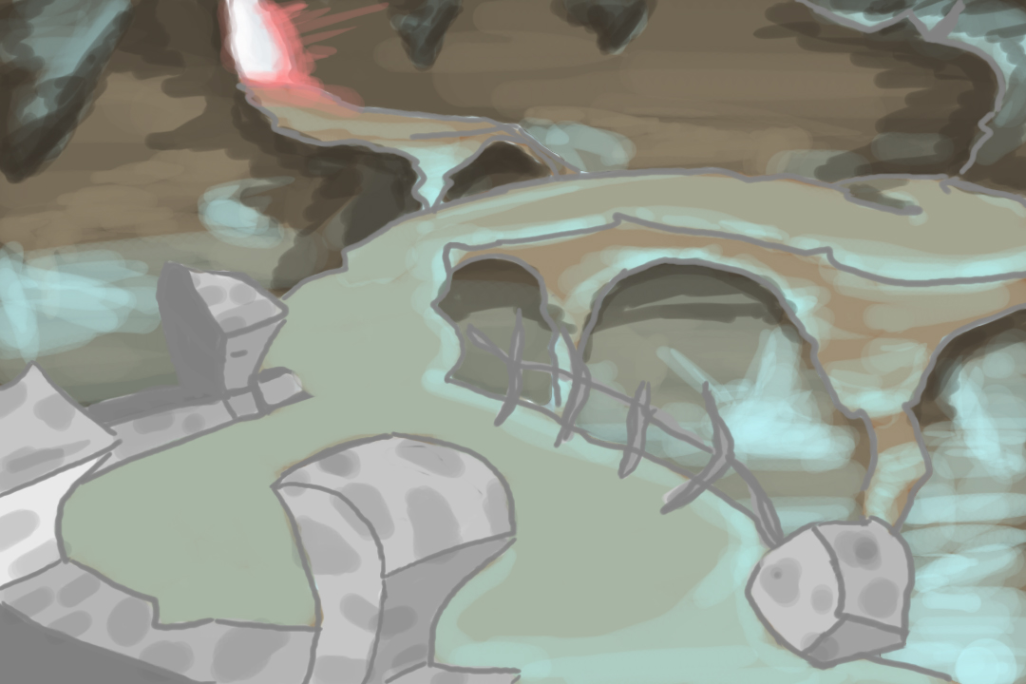
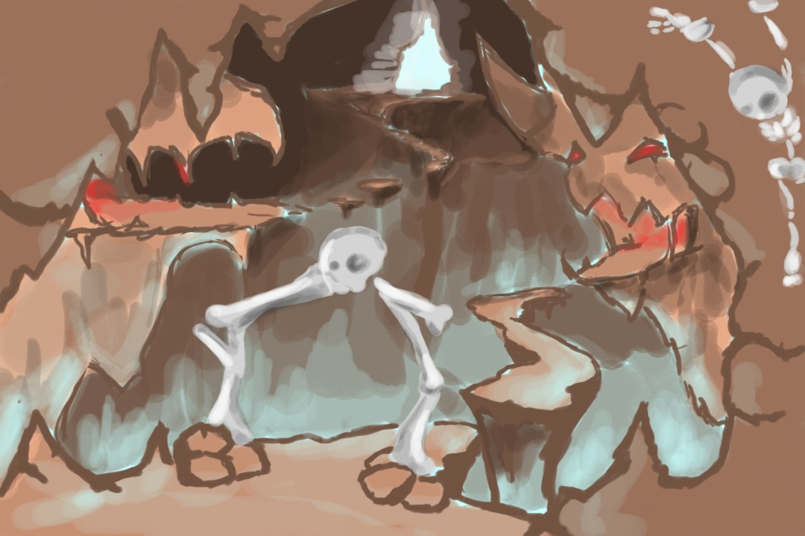
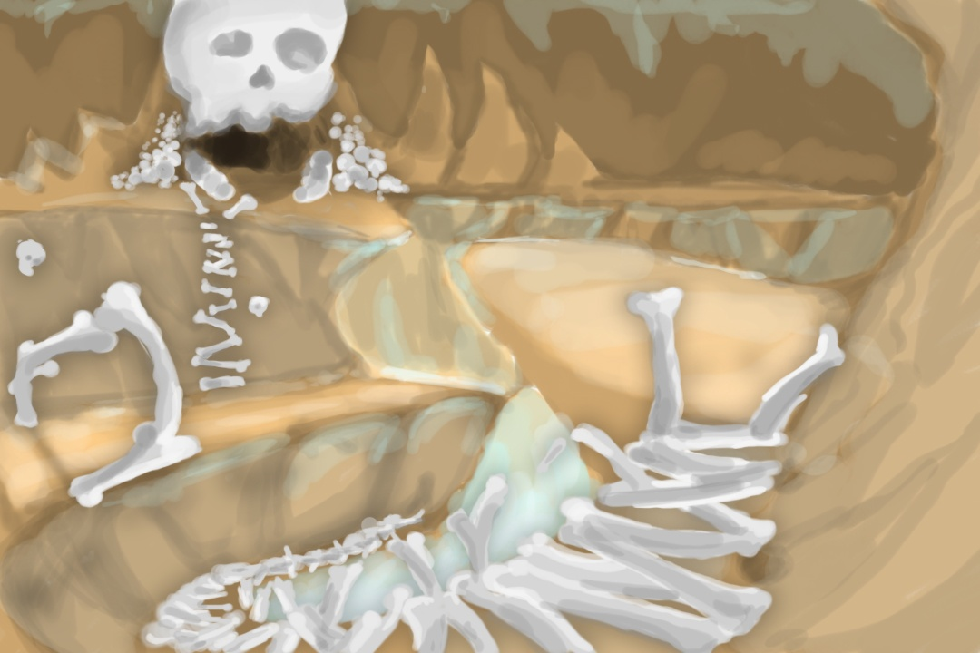
The Theme Park
Our theme park hell embodies two main environments the "front stage" and "backstage" areas. For the souls who are trapped there, the places looks and feels like an amusement park if it were set in the standard fire and brimstone Hell. For those who are native to the afterlife, torturing souls is just a day job. Beyond the walls of the "stage" (where the souls are tortured) there lies an expansive "backstage" area that is akin to the employee only areas of a theme park. The geometry of all our assets in game will be twisted and exaggerated similar to style seen in American McGee’s Grimm. Buildings will have their corners tapered and have uneven surfaces.
Style
Our principle art style is cartoony utilizing partial cell shading. For this we will use a custom built cartoon shader which we will apply to both our environment and characters. Our major objective with this is to create a painted comic book feel to the environment, if the game were paused at any point we would hope that the screen could be mistaken for an advanced concept art piece. We will have two different color schemes first the warm red and yellow palette that would be expected to be seen in hell, our second palette would be a cooler set of greens blues and fawns.
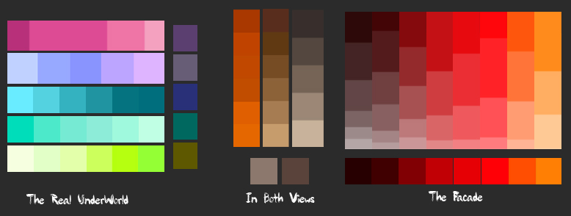
Main Characters (NEEDS APPROVAL)
Concepting
The first stage of character design involved the creation of dozens of silloettes all involving the chain mechanic, these were used to help narrow down the game fiction and the two main characters to their current iteration. The designers along with the rest of the team created the basic profile for our two main characters which ended up being the grim reaper intern and a recently deceased character. With these two in mind hundreds of other silloettes were created this time honing in on these two characters.
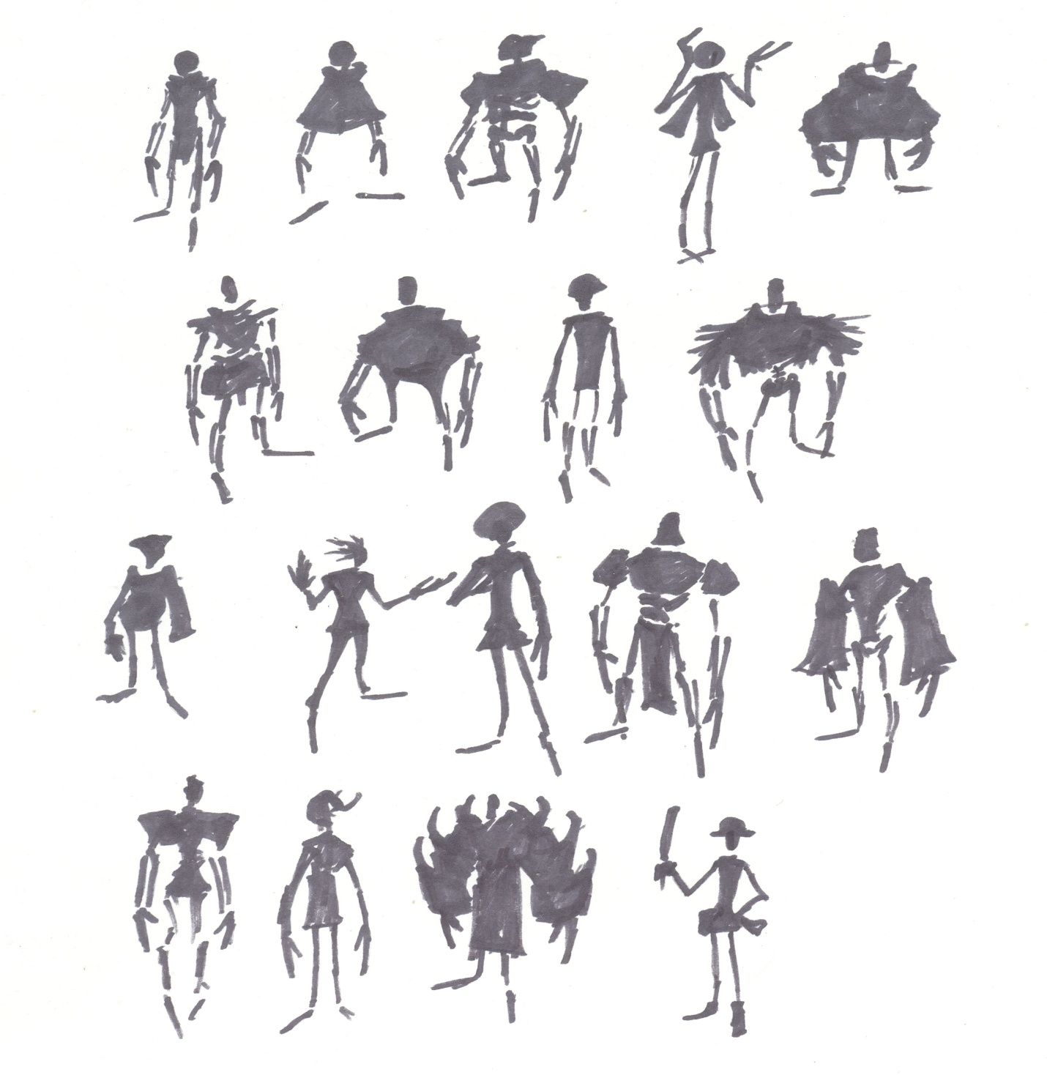
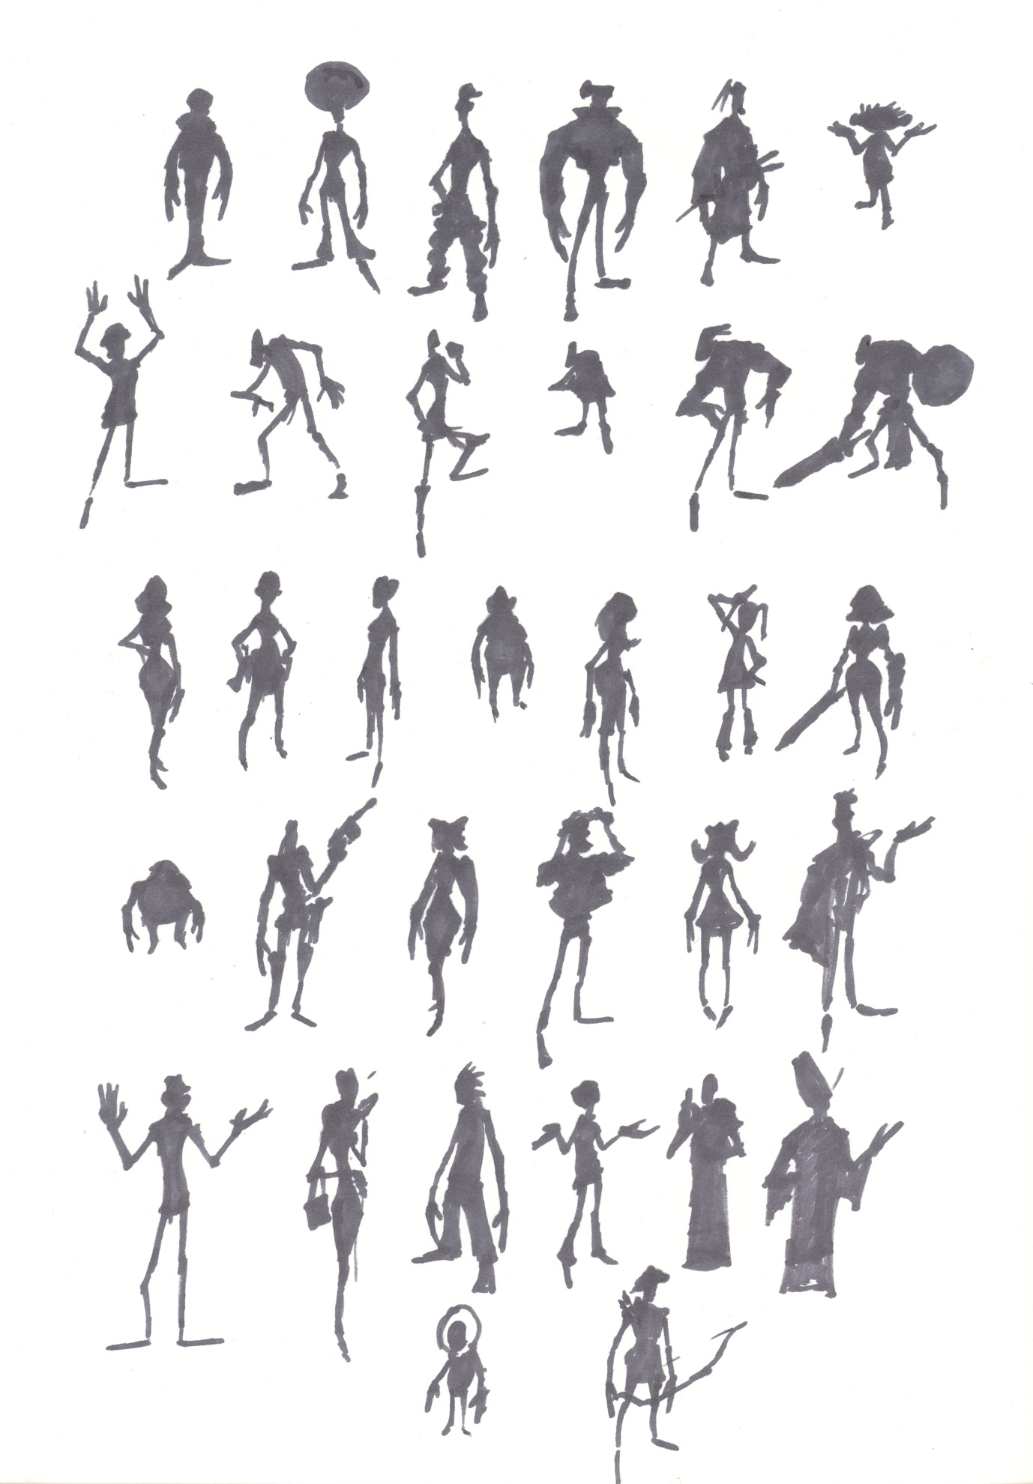
As distinctive characters started to emerge as strong aspects color concepts were created. Eventually a reel of each of the intended characters where drawn up and from there the team choose the strongest elements to be combined into the final character design.
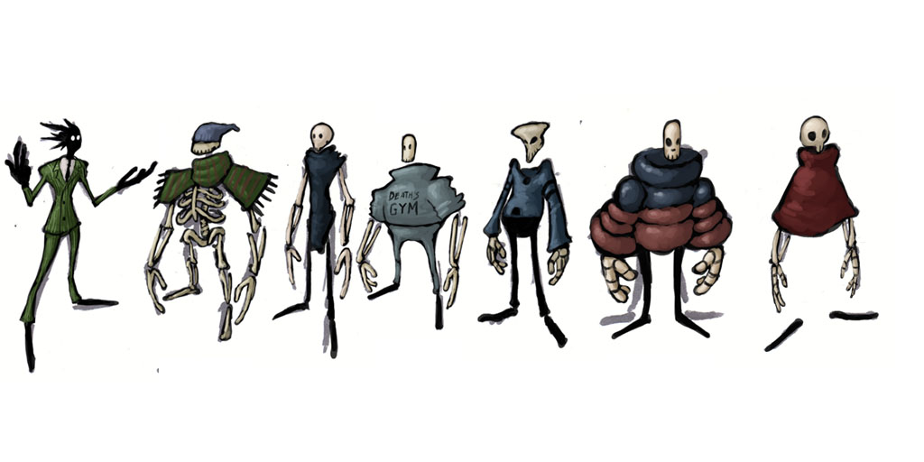

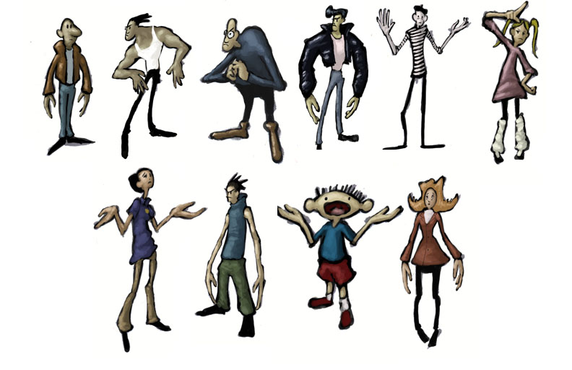
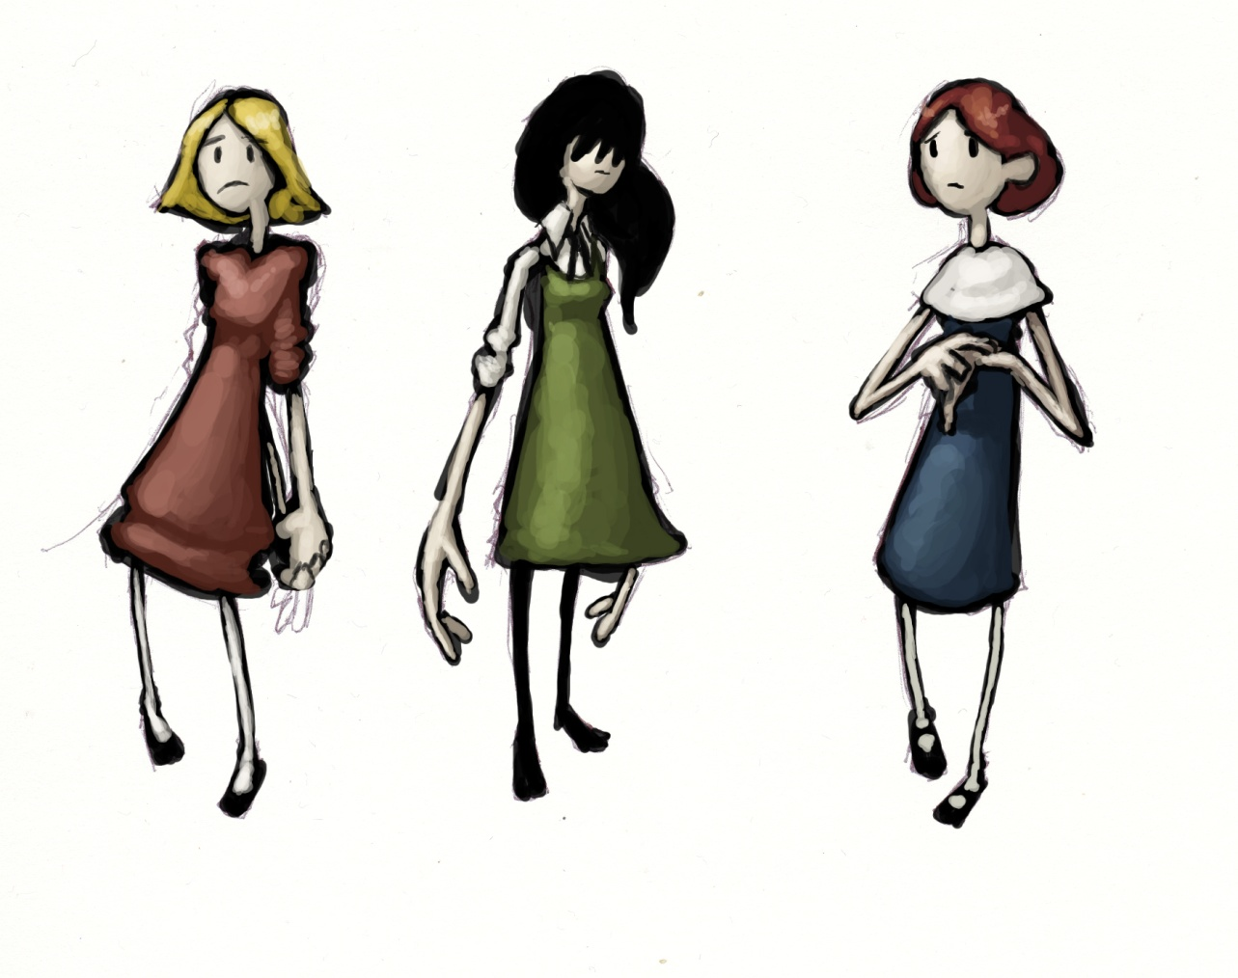
Posing
With final appearances for the two main characters set these were drawn out in orthographic t-poses to aid modeling.
Modeling
The two characters were then modeled in maya keeping to a limit of under 9000 polygons each. They were also rigged with stretch rigs for animation allowing their limbs to be stretched massively, this will enable the more extreme chain animations as well as supporting the cartoon exaggerated style. The models have also been UV’d and textured, the cartoon shader has also been tested on the characters.

Pipeline (INCOMPLETE)
Start typing here.
Tools (NEEDS APPROVAL)
Maya 2008
The principle reason for using 2008 over the newer 2009 version is that Maya 2009 is currently incompatable with the Gamebryo engine. The plug-in from Gamebryo to Maya allowing the creation of the .nif files is currently supported in 2008 but will not be upgraded to 2009 until May.
Photoshop, Illustrator & Zbrush
Our standard texturing tools which will be used in sync with maya to create assets as well as advanced concept pieces.
Custom Cartoon Shader
We are using this shader to create a unified cartoon style across all our assets that will match our artistic goal of creating a painterly feel within every frame of the game.
Scene Designer
Gamebryo’s built in Scene Designer will take on a great deal of the lighting concerns and prop placement in our level building.
Art Pipeline (NEEDS APPROVAL)
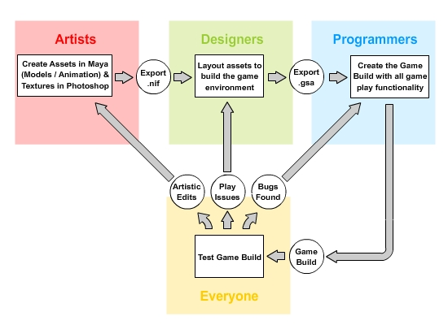Pipeline Overview
The diagram below demonstrates the basic pipeline process.
The artists to create game assets in Maya, these assets can either be static models or animated ones. Once created the artists will export these assets from Maya in the form of .nif files (GameBryo's default format) The designers using Gamebryo's Scene Designer will load in the .nif files and start to arrange these assets in the designer to create the game environment, layout obstructions, puzzles, etc with the intent of making the game as fun and compelling as possible. Once the level has been set up, lighted, etc the scene is exported as a .gsa file. The programmers will import the .gsa file and implement it into the game build. Everyone in the team will have constant access to the game build and will be able to compile and test it as required. Artistic corrections will be given to the artists, game play issues would go to back to the designers and bugs will go back to the programmers.
Automation
The intention of this set up is that any one of the three departments (art, design, programming) can make edits and check the result in the running build without having to bother either of the other two departments. A significant advantage of the GameBryo pipeline is that any changes made to any assets will automatically carry across the build, if an artist re-exports a .nif the designers will not need to update the .gsa scene file as the alteration will apply across the build automatically.
Blue Box Level Design
Our pipeline process in terms of building the environments first of all involves the designers shelling out a level plan using basic structures with a basic blue-wash texture. This methodology is very much akin to Valve’s Orange Box methodology. Once our level has had collision boxes added and is tested in engine the designers can make any adjustments necessary to improve playability or the ‘fun factor’. Once a final arrangement has been set this blue box shell is then handed over to the artists to be fleshed out, the artists will have the creative freedom to decide how best to dress the level. Any assets that are repeatable such as props will be added to the scene designer library of assets which the designers can then reuse when blueboxing future levels.

Asset Lists
Start typing here.
Sound Asset List (NEEDS APPROVAL)
Foley (for both Melvin and Sophie)
- Walking on:
  - Rocks
  - Wood
  - Metal
  - Bone
  - Water (maybe?)
- Running on
  - Rocks
  - Wood
  - Metal
  - Bone
  - Water (maybe?)
- Hitting
  - Stone Walls
  - Metal Poles
    - Girl meat hitting pole
    - Guy bone hitting pole
    - Chain hitting pole
- Climbing
  - Poles
  - Chain hitting poles
  - Climbing ledges
  - On one another
Chain sounds
- Hitting
  - Stone
  - Wood
  - Metal
  - Bone
  - Meat
Environmental Sounds
- General
  - Door creaks
  - Engine noises
  - Electric generator
  - Gear clanks
  - Backing up noise from vehicles
  - Hammer banging
  - Power drills
  - Lava flow / Bubbling lava
  - Screams / Shrieks
  - Dripping water
  - Electric humming
  - Scared sounding crowd
- Fire
  - Burn
  - Pop
  - Crackle
- Wood
  - Creak
  - Break through (hard fall)
  - Chop Hit
- Metal
  - Creak (gears, machinery, etc)
- Machinery
  - Whine / Drone
Character Collisions
- Walk / Run (Footsteps)
  - Dirt
  - Sand
  - Cavern
  - Hard Wood
  - Light Metal
- Bodies knock against (walk/run)
  - Hard Wood
  - Light Metal
- Bodies land (feet first) onto
  - Hard Wood
  - Dirt
  - Sand
  - Light Metal
  - Cavern
  - Cushion
- Bodies land (hard) onto
  - Hard Wood
  - Dirt
  - Sand
  - Light Metal
  - Cavern
  - Cushion
- Metal Chain knock against
  - Hard Wood
  - Dirt
  - Sand
  - Light Metal
  - Cavern
- Metal Chain slide against
  - Metal Pole
- Falling hard wood on
  - Dirt
  - Sand
  - Light Metal
  - Cavern
- Falling light metal on
  - Dirt
  - Sand
  - Hard Wood
  - Cavern
- Wind/Air
  - Blowing through cavern
  - Slow woosh as blade swings by
  - Strong burst from machinery
Technical Asset List (BOBBY)
Start typing here.
Art Asset List (NEEDS APPROVAL)
Torments / Parodies / Social Commentaries
- Rich man with nothing worth buying (Finally won the lottery before he died)
- Water boarding using beer
- Iron maiden - Blasting metal music to old people locked in a room
- Squwak box with a head inside Nothing but commercials on
- The rack as "weight buster 3000"
- Boiling cualdron as sauna
Backstage
- Paint Cans, Paint Brushes, Half Painted Scenery, Hair dryers (to dry paint)
- Ropes
- Cleaning supplies
- Dust Brooms
- Sanisore / vomit sawdust / cat litter, Sawdust
- Machinery, Pyrotechnics, Electric generators, Heaters, Fans, Wiring, Fuse box
- Spotlight, Strobe lights
- Oil drums, Propane tanks
- Smoke machines
- Fake Lava mixer, Sacks of Instant lava mix
- Broken props or props under construction
- Scaffolding
- Control Panels
- Pushing random buttons, affect environment?
- Excavation equipment, JCVs, Cranes
- Vending machines
- Storage boxes
- Punch clock, Lunch whistle
- Repairmen Foremen (Nail hand to wall) (Dump dirt on worker)
- Inanimate object characters (Giant hammer)
- Oversized costumes
- Trolls
- Syssuphis on a cigarette break, sitting against rock
- Shrunken head service telephone
Signs
- "Abandon hope" main gate sign reversed by "We put the 'ell in SWELL"
- Employees only, Do not enter
- "Twenty days since last accidental Resurrection"
- Universal Studios "We Will Win" vs. Heaven / Disney
- "Ask us about employment opportunities" cartoon stabbing
- Ironic Safety signs
- Demonic stickmen (Zero Punctuation-esque)
- Union signs
- "Where the hell am I?" Map
- Sin scale ("Fire - 5 Miles, Brimestone -10 miles, Heaven - Not a chance”)
Theme Park Specific
- Gift shop, Mugs, Copies of our game, Toy scythes
- Company Shuttle
- Costume Rack, Make-up stand
- Random costumes: Monsters, Bizarre mascot characters, Santa, Clowns, Bunny, Jesus
- Vendors: Soul food, life insurance, Ice Cream (in Hell)
- House of Mirrors
- Cardboard cut-out demons
- Tourist information
- Stocks as cardboard cut-out you can put your face in
- Weapon rack
Environmental Props
- Fire, and lots of it!
- River of lava
- Hidden switch to backstage
- Cage, Odd skeletons, chains
- Pair of skeletons chained together (One with a red hat)
- Throne of skulls
- Bone architecture
- Stalagtites/mites
- Organic sores, Little Volcanoes
- Shanty towns of coffins
- Coffins sticking out of the ceiling (Drops you into hell)
- Heads on pikes, talk
- Piles of ashes for cremation

Risk Analysis (MICHAEL)
Chain
Risk: High
The greatest inherent risk of the project is the chain mechanic itself. It is a highly complex programmatic task and although other games in the industry have included a chain such as ‘Whiplash’ and ‘The Maw’ none have attempted the level of interaction we are aiming for. In order to allievate the risks that the chain poses on the success of the project the level of sophisication that we will employ with the chain is variable, if we fail to achieve the full physics chain we can fall back to a more simplistic option.
Option 1: Straight Line / No Collision
The most basic form of the chain (our worst case scenario) would simply be a programmatically generated straight line between the two player characters that can shrink in size when they draw closer to one another, this could be presented as a energy based leach and would have no collision detection. This option however would eliminate many of the moves we have planned as well as detract somewhat from the quality of the final product.
Option 2: Context Sensitive Animations
The second option would be to almost completely animate the chain every move would be a boxed animation. The only exception would be when the players are walking or running around the environment in which case a set of joints could be used with PhyX attached. This line of joints could have basic collision detection against terrain.
Option 3: Full Physics Enabled Procedurally Generated Chain
Our goal is to create a programmatically driven chain with full collision detection and physics properties. All moves would simply involve animating the players with the chain free to ragdoll and interact with objects accordingly.
Number of Levels
Risk: High
Our current plan is for a small opening level followed by four full-fledged levels and one last smaller final level. It is unlikely that we would be able to achieve this without a very large team. In the probable situation that we have to cut down the number of levels we have classified three of the four levels as candidates to be cut if necessary, these have also been prioritized in the order in which they should be cut. The level progression is also planned so that any of these levels can be removed without adversely affecting the games fiction, pace or flow.
Personnel
Risk: Medium
Our team currently stands at 13 personnel, 4 designers, 4 artists, 4 programmers and 1 producer. We are anticipating a rise in this number as other personnel become available but in the situation that we do not gain new team members we will first of all have to scale back on the number of levels and secondly cut down the number of moves. Aside from these cut backs we anticipate that the existing team could still deliver the core essence of the game at the cost of reduced content.
Fun Factor
Risk: Low
Owing to the fact that the mechanic of two human controlled players chained together has never been done in a video game before we have no benchmark to know whether this form of gameplay is going to prove fun or not. Fortunately the platforming genre is a proven format for fun in gaming as well as cooperative gaming in general, ideally the merger of both as well as the unique premise of the chain will draw players in. In the event that the game is met with low enthusiasm during testing we may have to rely more on environmental design and humor to make the difference as well as endeavor to improve the game design wherever possible.
Chained Cooperative Mechanic Ill-suited to fast paced Gameplay
Risk: Low
We are currently planning on making our ten minute game experience largely a fast paced platforming game, we antisipate that the players will need a couple of minutes to get used to dealing with the chain but will then quickly take to it. It is possible however that instead the players will continuously struggle to move around with decades of single player platforming experience working against them. If this proves to be the case then we may have to change our direction towards a slower paced puzzle solving format.

Production Planning (DAN & BRIAN)
Start typing here.
Milestone Schedule (DAN & BRIAN)
Start typing here.
Development Methodology (DAN & BRIAN)
Our development methodology will consist of a mix between Scrum and Feature Driven Development. (FDD)
The main part of Scrum that we will use is its 15 minute standing meetings. Meeting at a set time every weekday will make sure all of the team members know who is working on what and what still needs to be accomplished. Having everyone stand during these meetings will help keep the meetings to their 15 minute time limit.
The part of FDD that will be used is its development periods. Each feature that will be in the game is given a set timeframe to be fully developed and polished. Once this timeframe ends, work will begin on the next feature. The Development Plan will house the prioritized list of features and their timeframes.
Appendix A – Chain Move Animations
Start typing here.

